

**Project Title:** Blinkit Dashboard Analytics

**Name of the Students:** Sourabh Kumar Dubey, Neeraj

Choudhary, Waris, Nazaf Ali Malik

**Registration Number:**

**Course and Semester:** MBA, 1st Semester ,Sec- B

**Submission Date:26/11/2024**

**Faculty/Guide Name:** Dr. Sourabh Poswal

**Executive Summary**

This Power BI project analyses Blinkit's performance across key business areas, including sales, customer preferences, outlet performance, and growth trends. The dashboard highlights a total sales revenue of **$1.20M**, driven by high-demand categories such as snack foods and soft drinks, with **regular-fat products** being the most preferred by customers.

Outlet analysis reveals that **Tier 3 locations** and **large-sized outlets** contribute the most to sales, indicating opportunities for expansion in similar regions and store formats. Sales trends show steady growth over the years, peaking in **2018**, reflecting the company’s strong market presence.

While the **average customer rating of 3.9** is decent, it suggests room for improvement in customer satisfaction. These findings provide actionable insights for inventory management, outlet optimization, and customer engagement strategies.

This project demonstrates how Power BI can be used effectively for data-driven decision-making, enabling Blinkit to identify growth opportunities and enhance its competitive edge.

**Table of Contents**

1. **Executive Summary**
2. **Introduction**
   * Context of the Project
   * Objectives
3. **Data Overview**
   * Data Sources
   * Data Description
   * Data Preparation
4. **Power BI Process**
   * Dashboard Design
   * Data Modelling
   * Visualizations
5. **Insights and Analysis**
   * Key Insights
   * Business Recommendations
   * Limitations
6. **Conclusion**

**Introduction**

**Context of the Project**

In the competitive landscape of quick commerce, **Blinkit** stands out as India’s premier last-minute delivery app. The app caters to customer demands for quick access to groceries, snacks, beverages, and other daily necessities. To ensure operational efficiency and superior customer experience, it is crucial to analyse business data comprehensively.

This project leverages Power BI to evaluate sales patterns, customer preferences, and outlet performance, enabling data-driven strategies for business growth.

**Objectives**

* Analyse total sales, sales trend, average sales, and customer ratings across various outlet types and sizes.
* Identify customer preferences based on item type and fat content.
* Examine the impact of outlet size and location on sales performance.
* Provide actionable recommendations for business improvement.

**Data Overview**

**Data Sources** The data was obtained from Kaggle(excel sheet) and includes

* Outlet-related details such as location, type, size, and establishment year.
* Item details, including categories, fat content, and sales performance.
* Customer feedback data used to calculate average ratings.

**Data Description**

The Blinkit Grocery Data provides a comprehensive overview of grocery items and their associated outlets, encompassing **8,523** entries with **12 key attributes**.

The dataset includes columns such as 'Item Fat Content', 'Item Identifier', 'Item Type', 'Outlet Establishment Year', 'Outlet Identifier', 'Outlet Location Type', 'Outlet Size', 'Outlet Type', 'Item Visibility', 'Item Weight', 'Sales', and 'Rating'.

These columns offer insights into the characteristics of grocery items and the outlets where they are sold

**Data Preparation**

**Data collection**: The raw data was imported from an online Excel sheet, which contains all the relevant fields for analysis. This Excel file was then loaded into Power BI.

**Data Cleaning**: Missing values or null values was replaced with 0. LF was replaced by low fat in the entire sheet and reg was replaced by regular fat.

**Data Transformation**: all unnecessary and unused columns are then removed like item visibility, 'Item Identifier', 'Item Weight', 'Outlet Identifier' according to my insights.

**Loading into Power BI**: o After preparation, the finalized dataset was loaded into Power BI. This environment provided an interactive platform for creating visualizations and dashboards. Filters, slicers, and interactive charts were set up to enhance data exploration and support detailed analysis of the dealership’s sales and customer metrics

**Power BI Process**

**Dashboard Design**

The dashboard employs a bright yellow-green theme inspired by Blinkit’s branding, designed to ensure readability and visual appeal. Key KPIs, such as Total Sales ($1.20M), Average Sales ($141), and Average Ratings (3.9), are prominently displayed.

The layout is divided into key sections:

**Visualizations**

1. **KPIs:**
   * Total Sales: $1.20M
   * Average Sales per transaction: $141
   * Total Items Sold: 8,523
   * Average rating: 3.9.

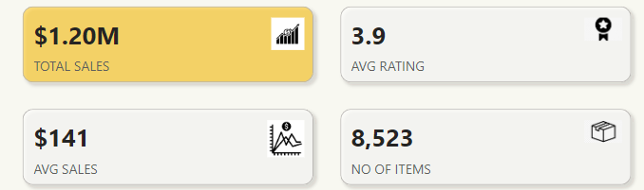

1. **Pie Charts and donut chart:**
   * Fat Content: 64.73% of items sold are regular fat, while 35.27% are low-fat**. (pie chart)**
   * Outlet Size Contribution: High-size outlets contributed 42.27% of sales**. (donut chart)**

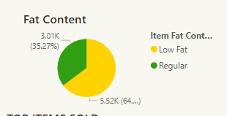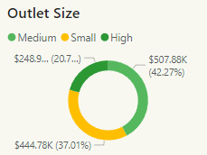

1. **Filters (Slicers):**
   * **Outlet type**: Allows filtering by a outlet type.
   * **Outlet location**: Enables viewing by tier wise.
   * **Item type**: : Enables viewing by specific item type.

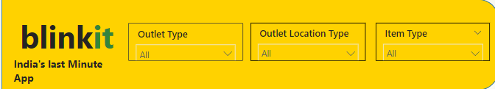

1. **Bar Charts and line chart:**
   * Top-performing item types: Snack Foods, Soft Drinks, and Starchy Foods. (bar chart).
   * Revenue by item type (clustered bar chart) with highest revenue by snack and vegetables $178K.
   * Sales by outlet establishment year (line chart).
   * Sales Trends: Significant sales growth noted between 2016 and 2018, peaking at $205K in 2018.

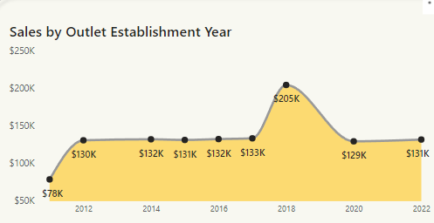

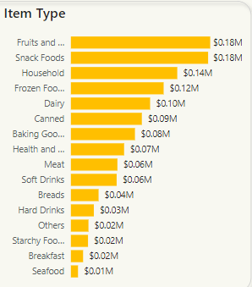

1. **Matrix (outlet information):**

* **Grocery Stores**: $1.52M total sales, with $140.29 average sales per transaction.
* **Supermarket Type1**: $7.87M total sales (highest), $141.21 average sales.
* Supermarkets outperform grocery stores, possibly due to higher inventory and footfall.

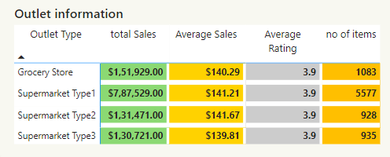

1. **Funnel (outlet location).**

This shows the Outlet Location Performance.

* Tier 3 locations dominate sales, contributing $472.13K, followed by Tier 2 ($393.13K) and Tier 1 ($336.39K).
* The higher contribution from Tier 3 suggests the app is more popular in less urbanized or semi-urban areas.

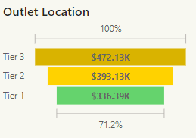

**Insights And Analysis**

**Key Insights**

1. **Overall Sales Performance**

* The total sales revenue for the period analysed is $1.20M, indicating significant business activity across outlets.
* The average sales value per transaction is $141, highlighting the tendency of customers to make moderately high-value purchases.
* A total of 8,523 items were sold, showing a healthy volume of transactions.
* The average customer rating is 3.9, suggesting a fairly positive but improvable customer satisfaction level.

2. **Item Preferences**

* **Customer Preference for Regular-fat Products**:
  + 64.73% of items sold are regular-fat products, indicating a clear customer preference for these items over low-fat alternatives (35.27%).
  + This aligns with trends in popular categories such as snacks and soft drinks, which are typically regular-fat.
* **Top-performing Item Categories**:
  + Snack Foods: Contribute $0.18M, the highest among all item categories, making them the most popular choice.
  + Soft Drinks: Another high-performing category, generating $0.18M in sales, closely tied with snack foods.
  + Starchy Foods: The third most popular category, contributing $0.16M, showing steady demand among customers.
* **Insights for Inventory:**
  + Regular-fat and high-demand categories like Snacks and Soft Drinks should be prioritized in inventory management to meet customer demand consistently.

3. **Outlet Performance by Size and Location**

* Sales Contribution by Outlet Size:
  + High-size outlets contribute the largest share of revenue, totalling $507.88K (42.27% of total sales).
  + Medium-size outlets follow closely with a contribution of $444.78K (37.10%), indicating their strategic importance.
  + Small-size outlets account for $247.33K, with a lower contribution but potential for growth in specific areas.
* **Sales Performance by Outlet Location (Tier):**
  + Tier 3 outlets dominate with total sales of $472.13K (39.34% of overall revenue), showing their high potential in less competitive markets.
  + Tier 2 outlets follow with $387.13K, while Tier 1 outlets generate $340.89K, reflecting stronger competition in urban areas.

4. **Trends in Sales Growth Over Time**

* Year-over-Year Sales Trends:
  + Sales have grown steadily from 2012, reaching their highest point in 2018, with a revenue peak of $205K.
  + The data shows a clear upward trajectory in revenue, suggesting consistent business growth over time.
  + This trend underscores the importance of analysing seasonal or year-specific factors contributing to these peaks.

5**. Customer Ratings and Satisfaction**

* The average customer rating of 3.9 suggests room for improvement in customer satisfaction.
* Although not poor, maintaining or increasing this rating will be crucial for long-term customer retention and loyalty.
* Future analysis could include qualitative feedback to understand specific areas where improvements can be made.

**Business Recommendations**

1. Expand high-size outlets in Tier 3 locations to capitalize on their revenue potential.
2. Focus on marketing regular-fat items, especially Snacks and Soft Drinks, to align with customer preferences.
3. Regularly monitor sales trends to identify potential seasonal spikes or declines.
4. Optimize inventory for high-demand categories to reduce stockouts and improve customer satisfaction.

**Conclusion**

The analysis of Blinkit's performance using Power BI provides valuable insights into sales, customer preferences, and outlet performance. Key findings indicate that the company has achieved strong total sales of **$1.20M**, driven by popular categories such as snack foods and soft drinks. The preference for **regular-fat products** among customers highlights an opportunity to focus on high-demand inventory items.

Outlets in **Tier 3 locations** and **large-sized stores** are the most significant revenue contributors, suggesting that expanding operations in similar areas could drive further growth. The **consistent growth in sales over the years**, with a peak in 2018, demonstrates the company’s ability to sustain and expand its market presence.

However, the **average customer rating of 3.9** highlights the need to improve customer satisfaction through better services or enhanced product quality.

This project underscores the importance of data-driven decision-making in optimizing sales, managing inventory effectively, and identifying key areas for expansion. By leveraging these insights, Blinkit can enhance its operational strategy, boost customer loyalty, and achieve greater profitability in the competitive retail landscape.